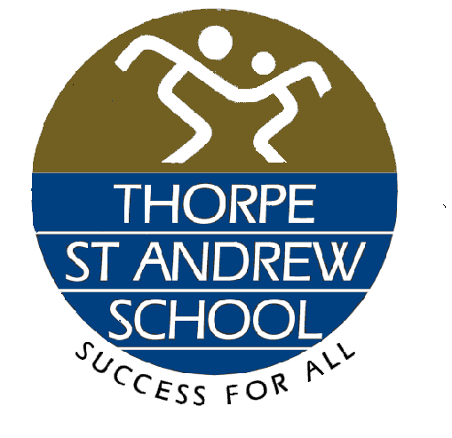

Dear Parents/Carers

Introduction

Following the recent announcement from the Government , the school received notification from the Department of Education that the school will move to remote learning throughout the period of national lockdown due to COVID 19.
Students will be able to access remote learning via Google Classroom details of which are explained below.

Remote Learning
From Monday 11th January 2021 until further notice we will be following “blended learning” for students in all Year groups.

Students should follow their normal timetable (see times below) and access remote learning work via Google Classroom from their RM Unify accounts. All students should have joined the Google classroom for each subject they have.

Lesson 1: 8.25 -9.25
Lesson 2: 9.35 - 10.35
Lesson 3: 10.50 - 11.50
Lesson 4: 12.00 - 13.00
Lesson 5: 14.00 - 15.00

All classes will have “blended learning” live lessons for the week commencing Monday 11 January 2021. This does not mean that the whole lesson is live – that is not always appropriate. The model teachers may follow is -
- Greeting and welcoming students where a formal register is taken
- Retrieval quiz starter, either through a google form while setting up the google meet or as soon as the Google meet starts
- A live input from the teacher in the google meet. This will not last the whole lesson.
- An activity or task, offline. During this time, you will be able to contact your teacher to ask for help or to explain the task if you don’t understand
- Submission of activity on Google classroom for checking, or evidence of work completed. This can be a photograph submitted of written work
- A plenary, online in the google meet or a google form to check understanding.
The “blended learning” lesson may not always be exactly like this model, but it will always begin with a live introduction from the teacher and a register taken for that lesson.
Class teachers will continue to use class charts to award ARE points and to identify where students may need further support. If this is the case parents and students will be contacted via the relevant Head of Year or BEST Team. If there are any concerns regarding remote learning please contact the relevant class teacher in the first instance or the Year group leadership team
If you do not have the contact details of the class teacher please email office@thorpe-st-andrew.norfolk.sch.uk clearly labelling in the subject heading FAO teacher name and it will be forwarded on to them.
The only exception to this format of remote learning is for core PE. The PE department has uploaded videos and guidance for exercise on their google classroom.

Joining Google meet lessons ( guide for students)
- All classes have a google classroom. In that google classroom you will see a “meet link” under the title of the class. 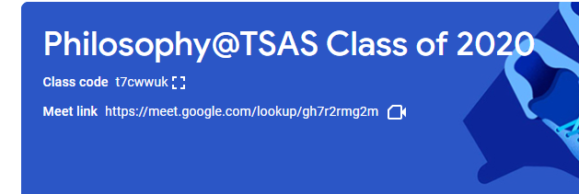

Use this link to join your live lesson.
- If you haven’t joined a classroom your teacher will post the class code on class charts again. You must then join the google classroom for that subject or teacher. That is where all of the work will be for that lesson. For students who do not join the lesson, instructions and activities will be available for them in the classroom during the day.
- If you have any problems joining a lesson, email your teacher. You are able to do this through the google classroom if you don’t have your teachers email address.
You will be following your normal timetable during this time. Be punctual for these lessons and be ready to learn!
We have surveyed all parents/carers regarding access to an internet enabled device and have not recalled laptops and Chrome Books loaned in March 2020 to ensure all students can access the remote learning provision. Please inform the school via office@thorpe-st-andrew.norfolk.sch.uk if circumstances have changed and remote learning would be difficult for your son/daughter, we will respond to communication from Monday 4 January 2021. The Government has provided us with a limited number of Chrome Book devices to loan for student use during periods of school disruption. We do not want the lack of access to technology to be a barrier to our remote learning provision and we will do our best to help.

Please contact itsupport-tsa@yare-edu.org.uk for any queries regarding RM Unify/Google classroom or use of devices, they will respond as soon as possible from Monday 4 January 2021. For subject specific questions and queries students should contact their teachers via Google Classroom.

Further help with google classroom can be found here -
https://support.google.com/edu/classroom/answer/6020285?co=GENIE.Platform%3DDesktop&hl=en

Important Contact Information
- For subject specific questions and queries students should contact their teachers via Google Classroom.
- For IT issues, including RM Unify/Google classroom or use of devices please email itsupport-tsa@yare-edu.org.uk
- For student absence please contact the school in the normal way, via the absence line 01603 497722.
- For COVID-19 issues over the holiday period, please email trackandtrace-tsa@yare-edu.org.uk, this email will be monitored daily
- For any other queries please email office@-thorpe-st-andrew.norfolk.sch.uk

Thank you for your ongoing support and cooperation in these times. I wish you a safe and Happy 2021.

Yours faithfully
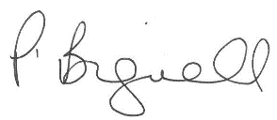

Mrs P Bignell
Principal

